Select Your Operating System (OS): Choose an operating system that best suits your preferences and project requirements. Download and Install Windows 11. <https://www.microsoft.com/software-download/win>

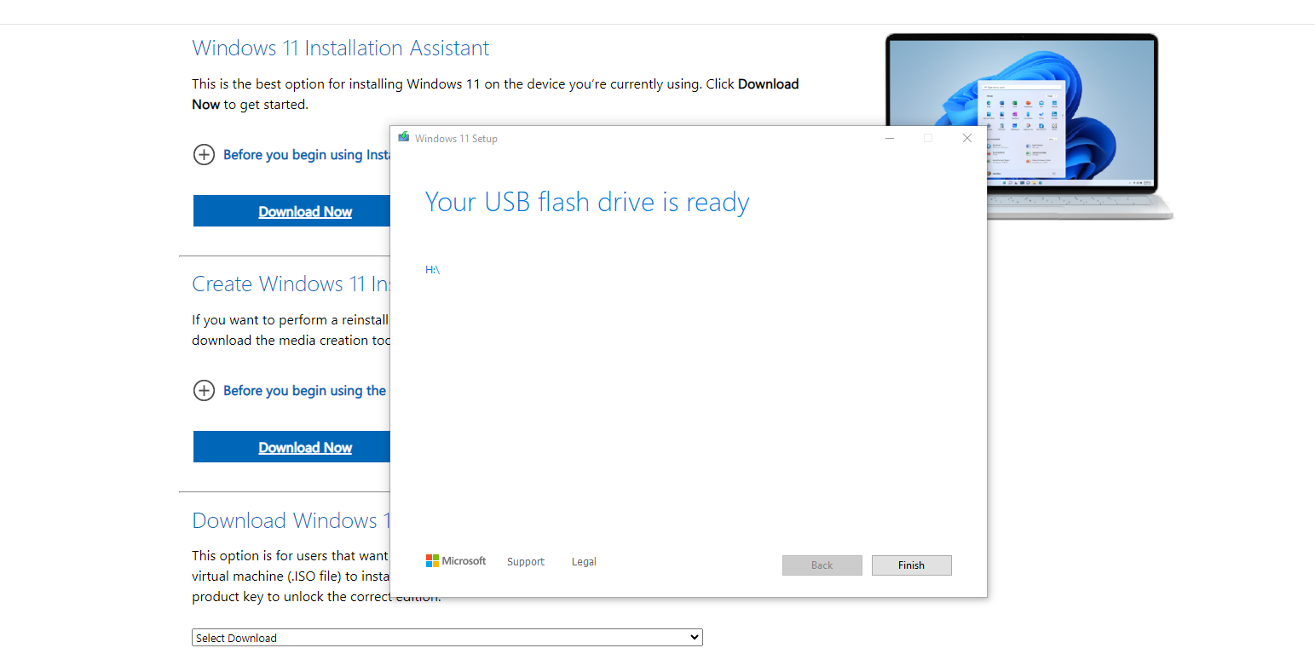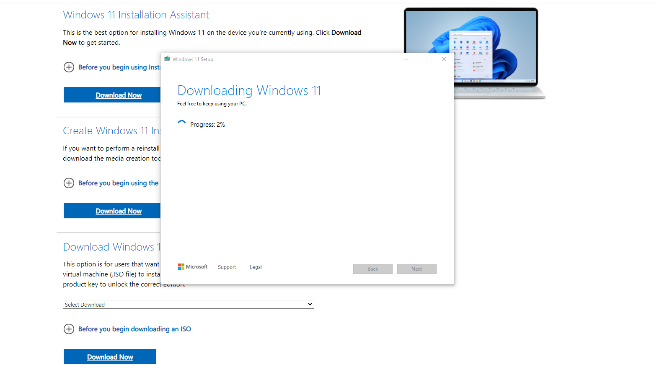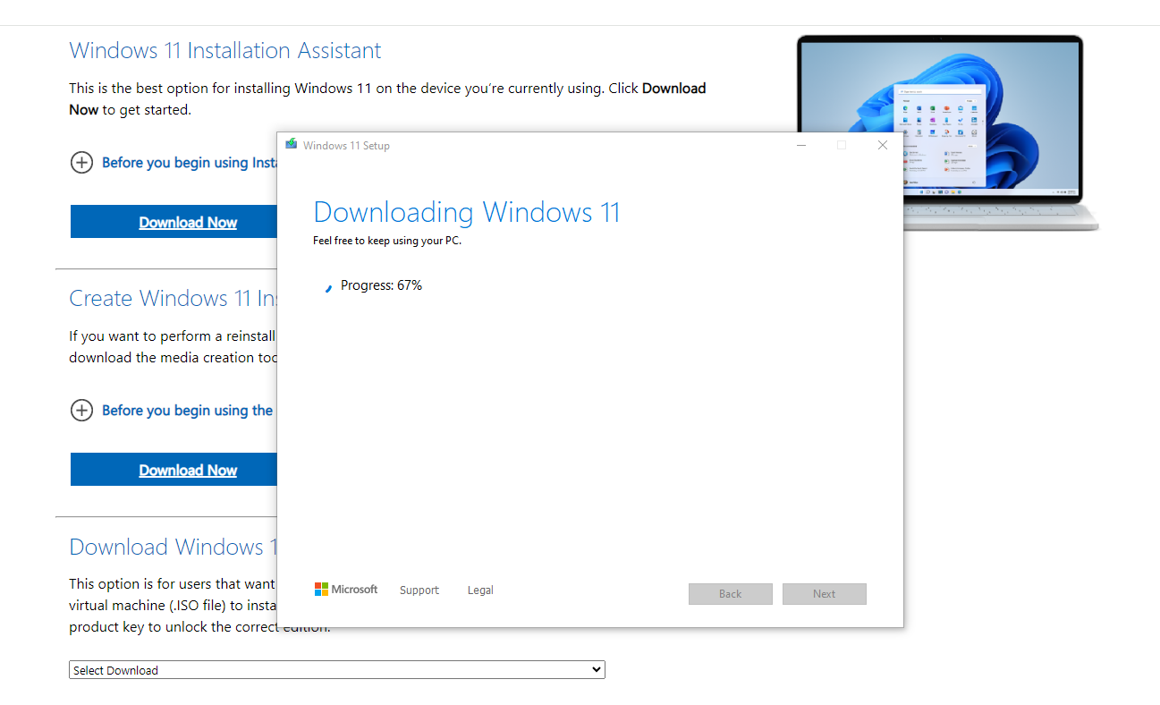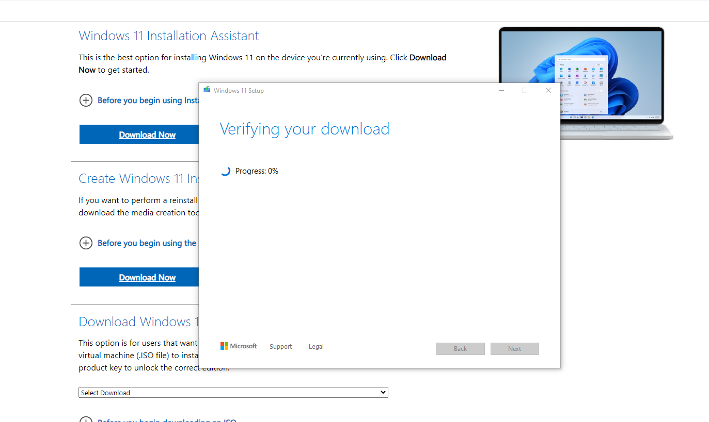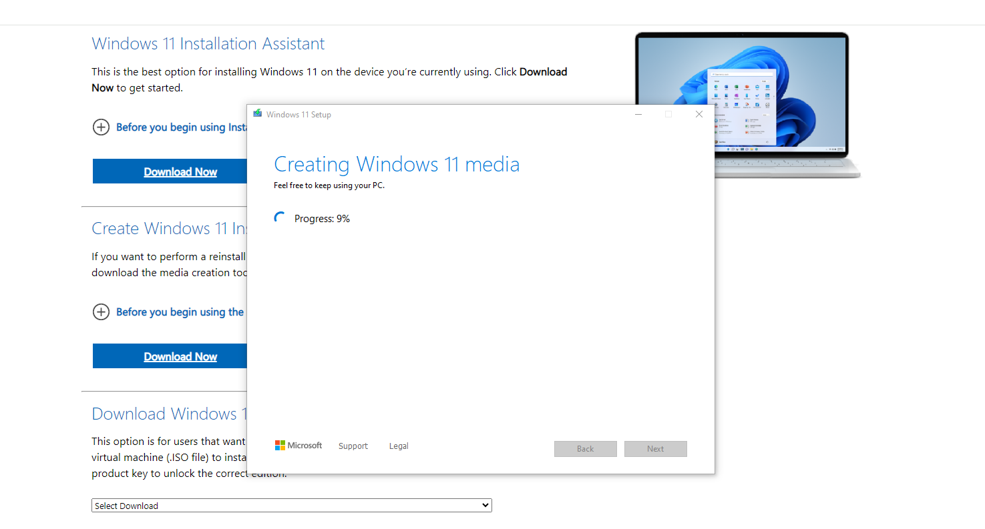

Challenges Encountered:

1. My PC did not support Windows 11 installation but used a USB
2. Install a Text Editor or Integrated Development Environment (IDE):

Select and install a text editor or IDE suitable for your programming languages and workflow. Download and Install Visual Studio Code. https://code.visualstudio.com/Download

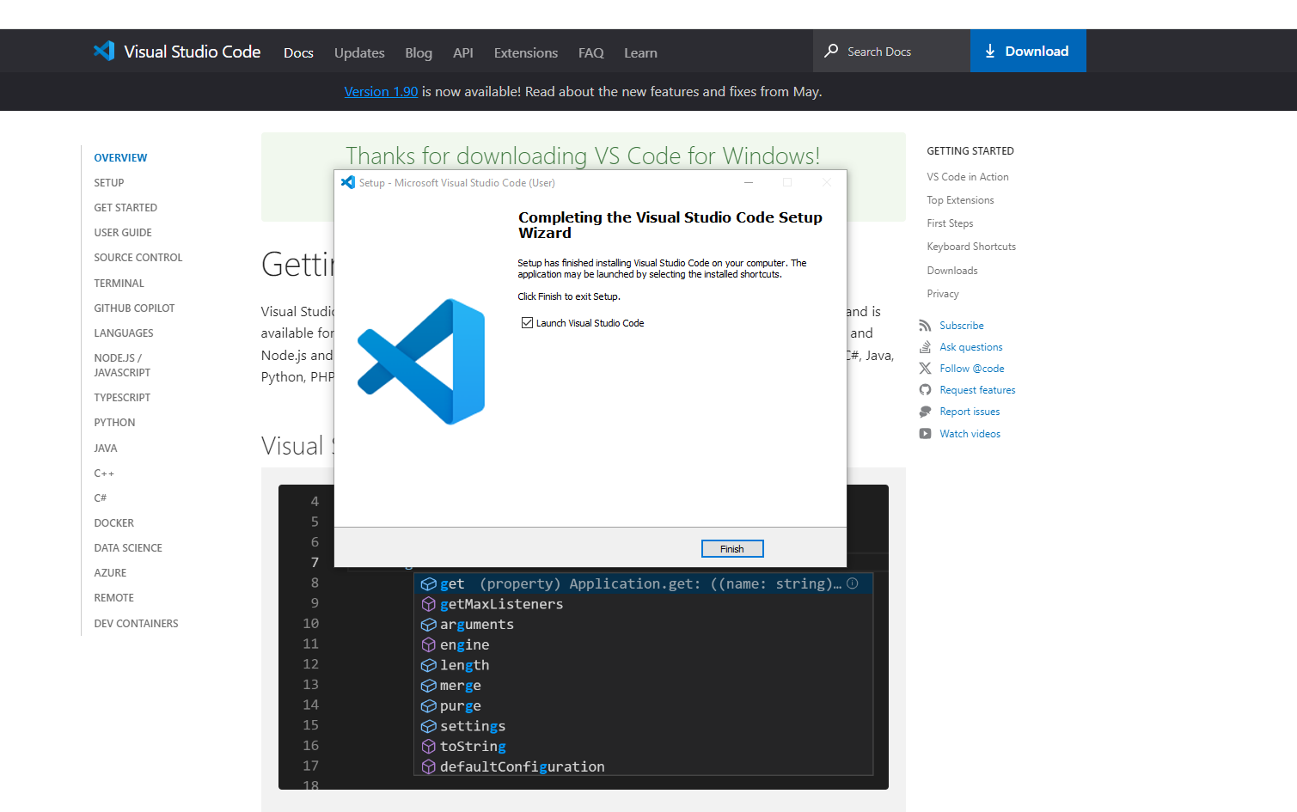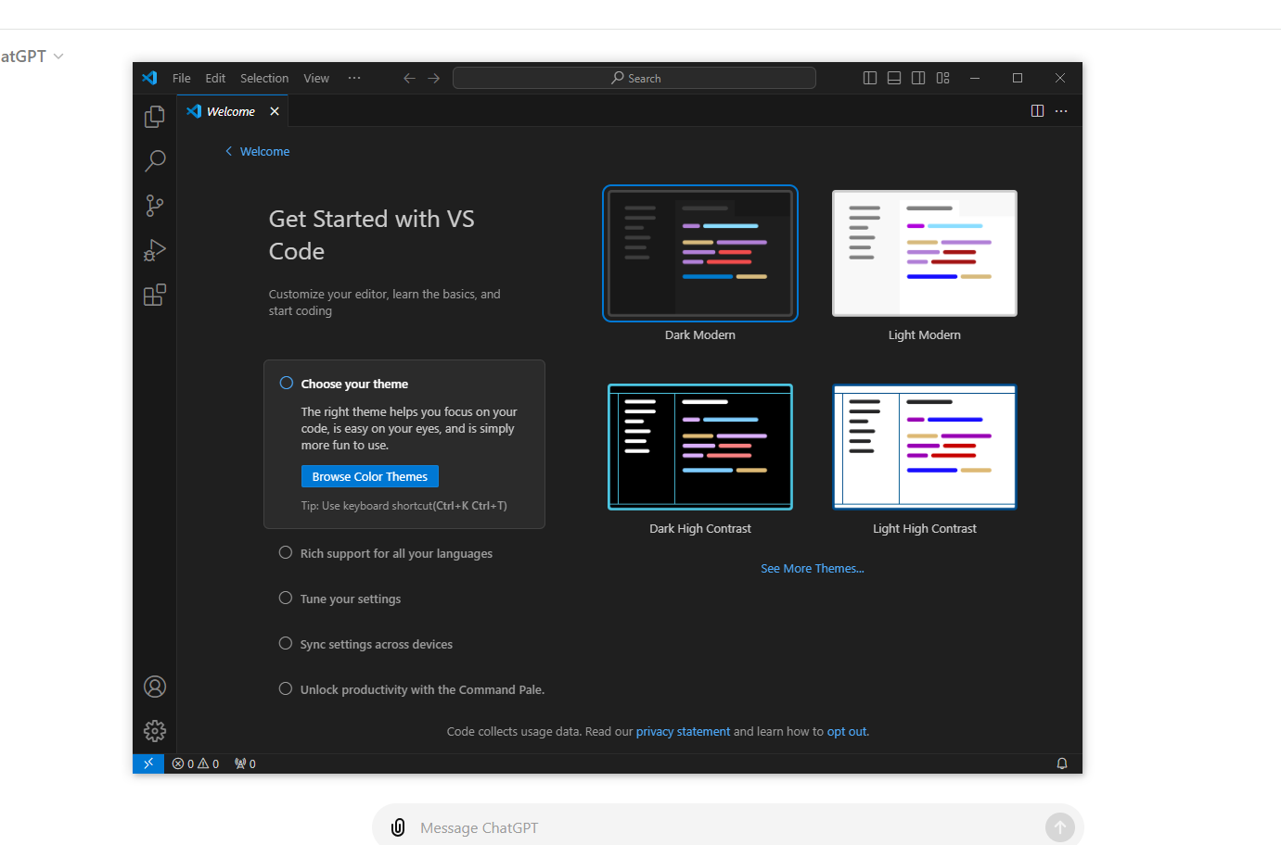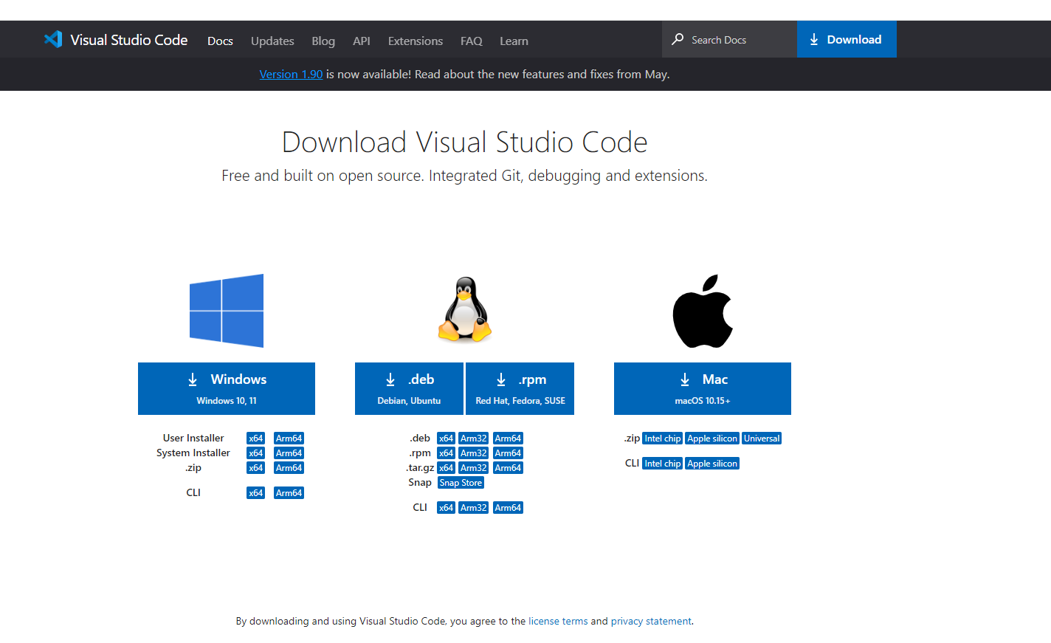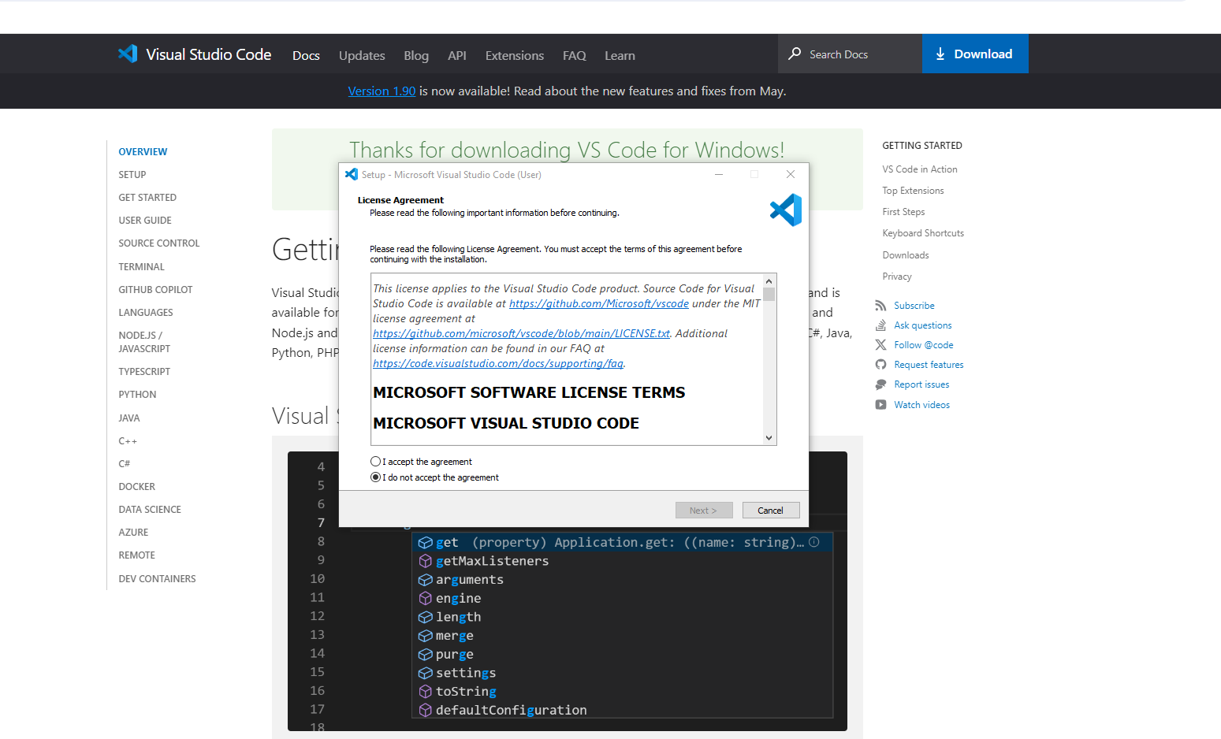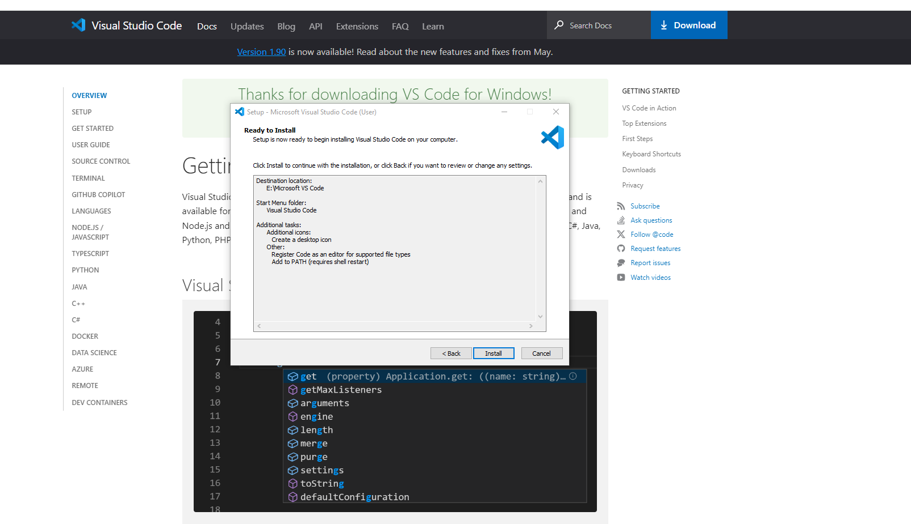

Successfully Installed.

1. Set Up Version Control System: Install Git and configure it on your local machine. Create a GitHub account for hosting your repositories. Initialize a Git repository for your project and make your first commit. <https://github.com>

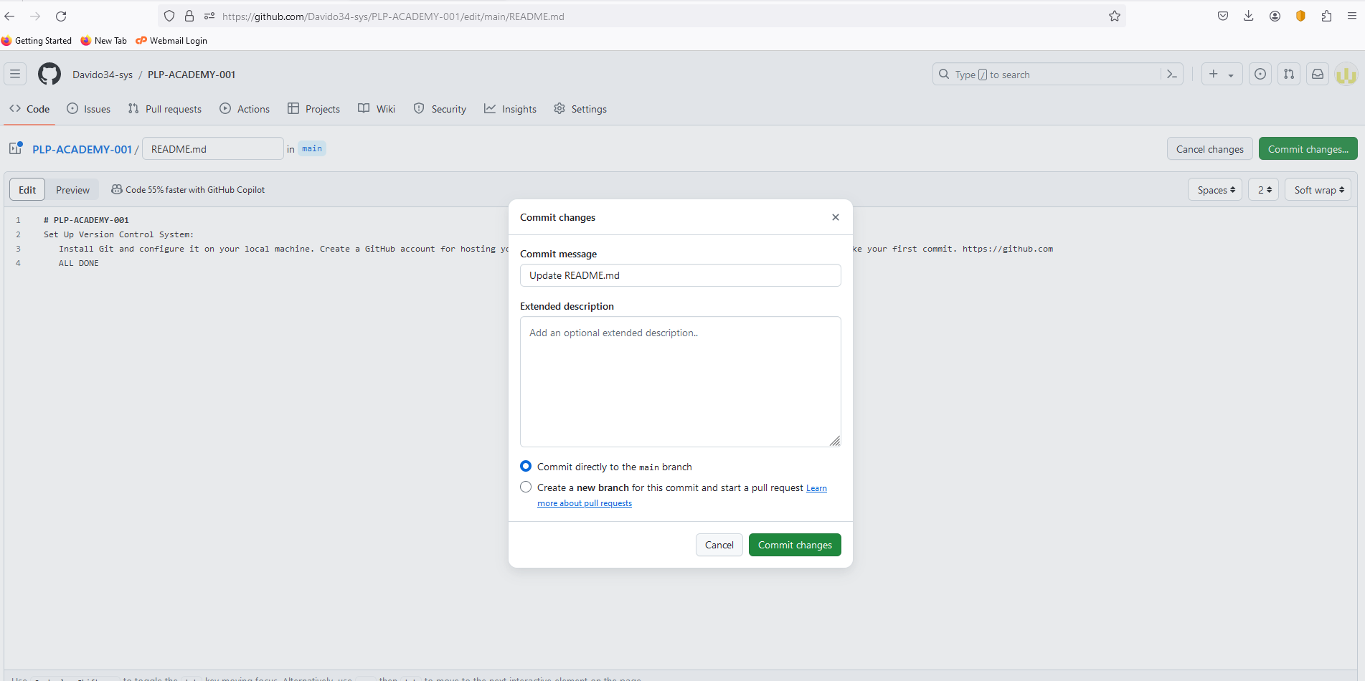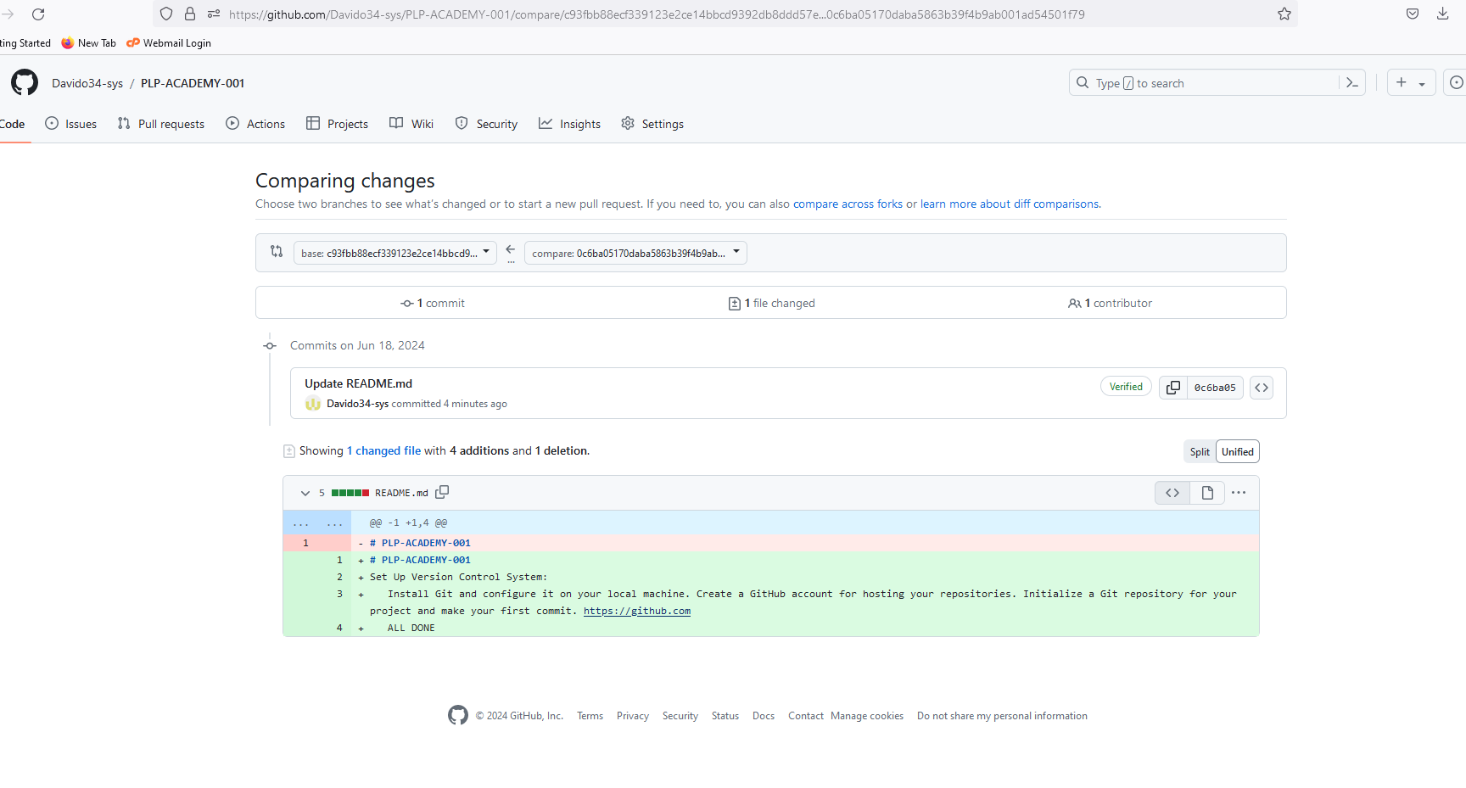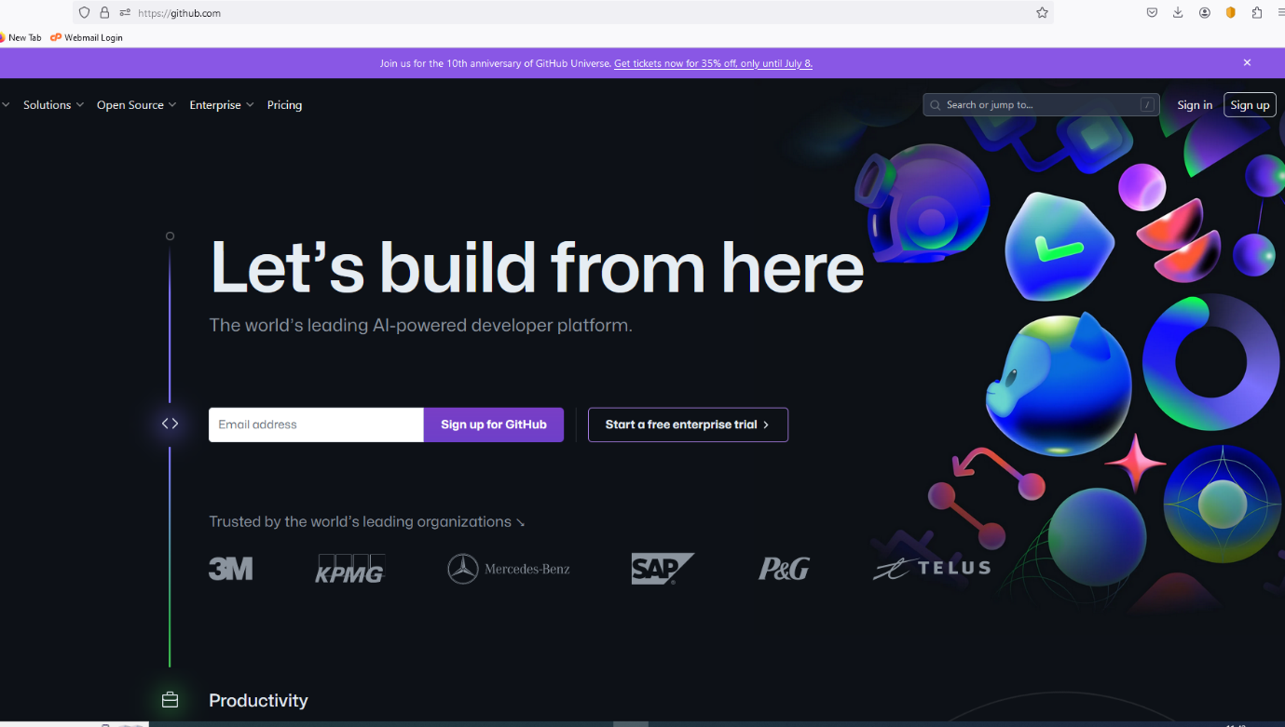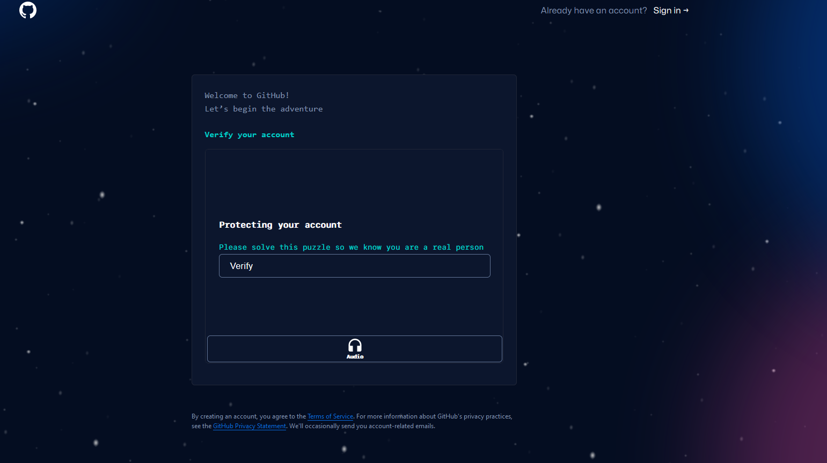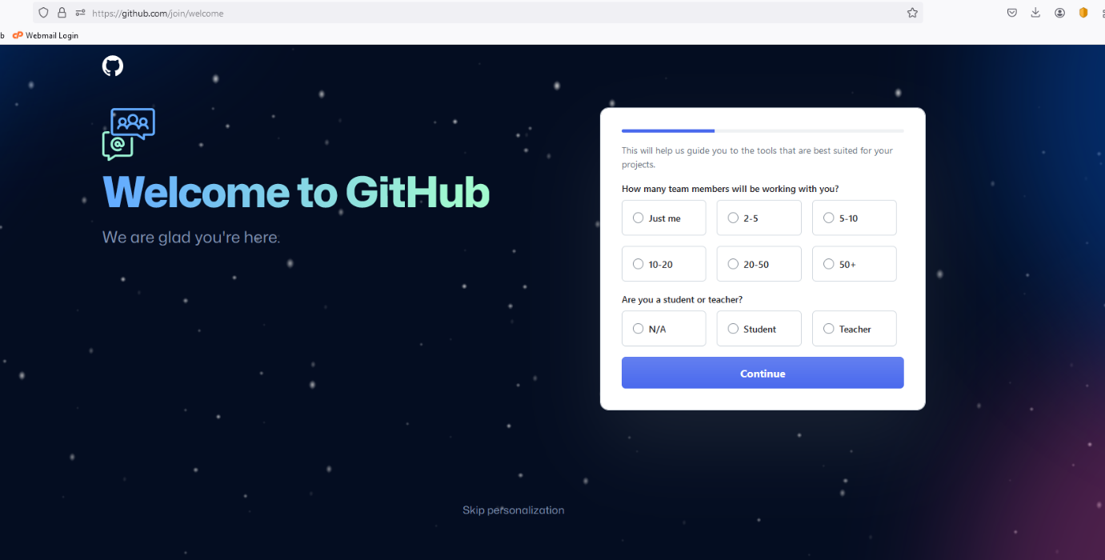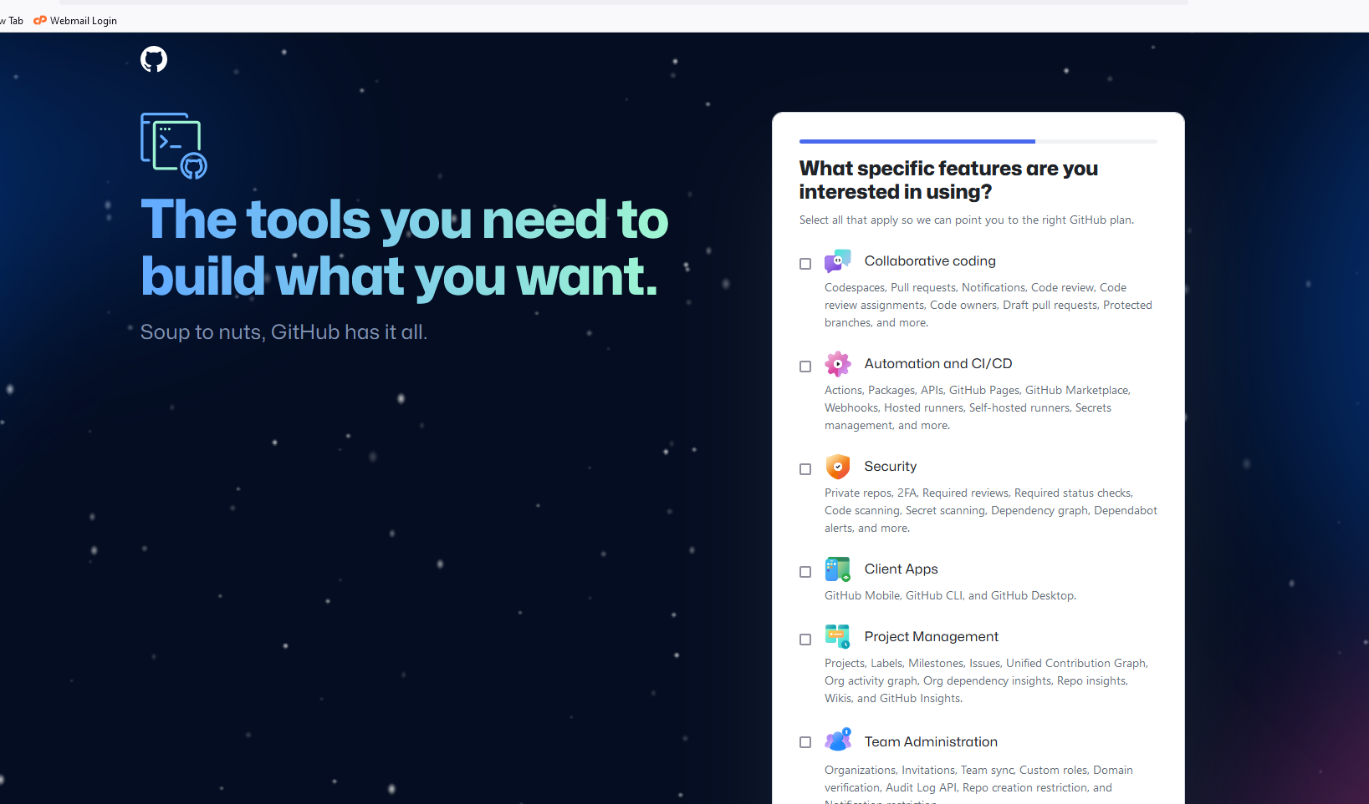

I successfully created a GitHub account.

**Install Necessary Programming Languages and Runtimes: Instal Python from http://wwww.python.org programming language required for your project and install their respective compilers, interpreters, or runtimes. Ensure you have the necessary tools to build and execute your code.**

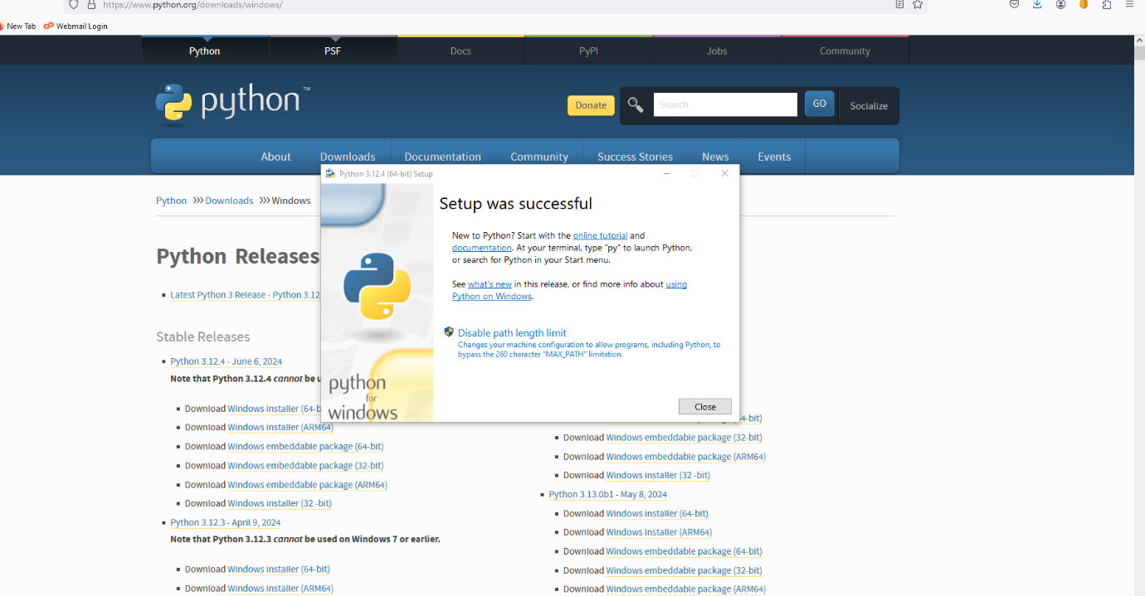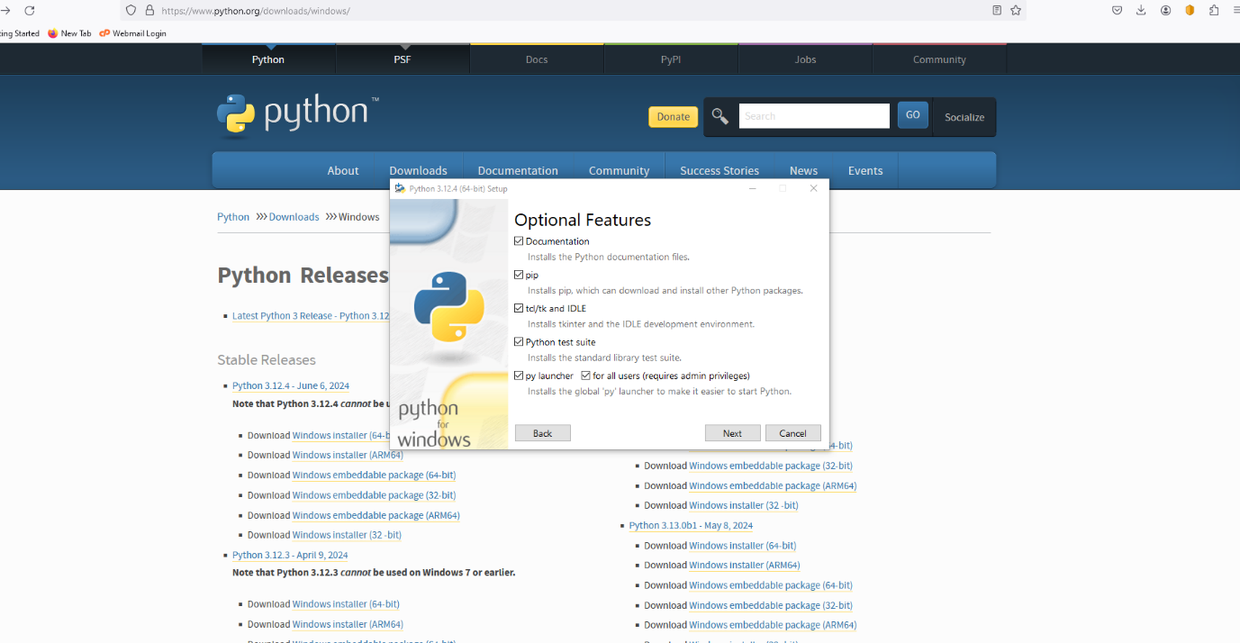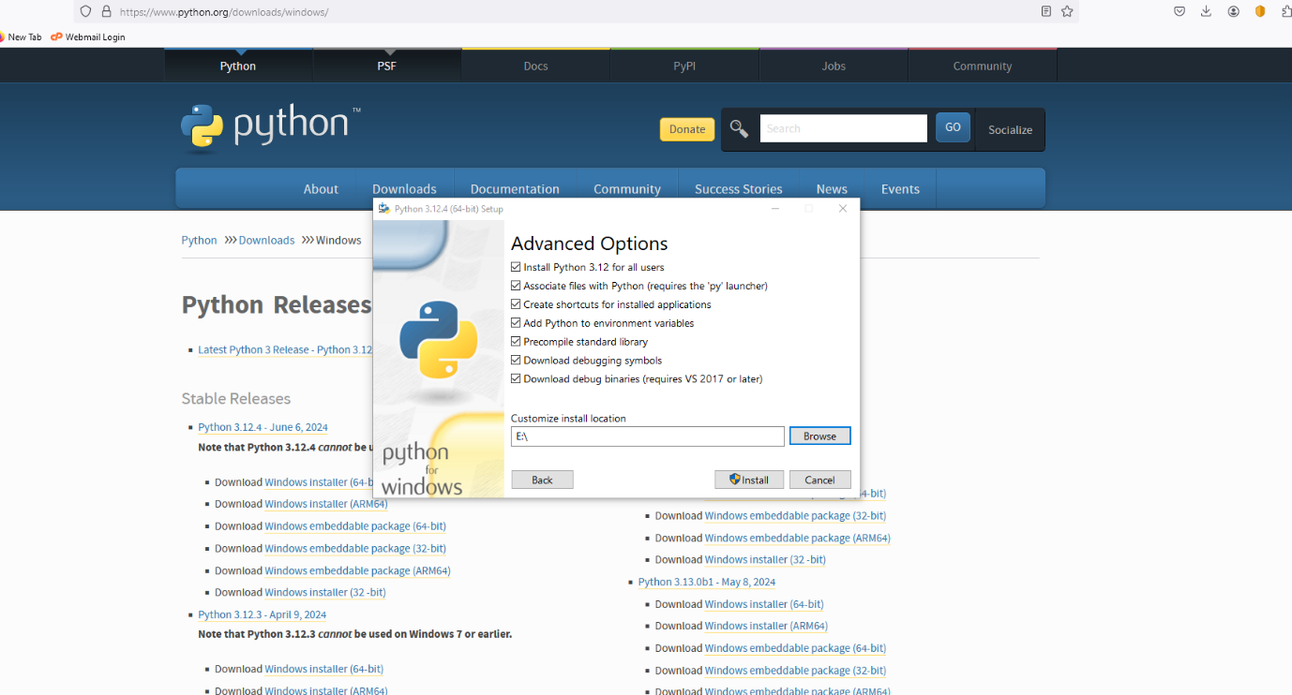

**Successfully installed python**

**Challenges:**

**Unable to execute codes**

**Install-Package Managers: If applicable, install package managers like pip (Python). Unable to do so.**

**9. Configure a Database (MySQL): Download and install MySQL database.** [**https://dev.mysql.com/downloads/windows/installer/5.7.html**](https://dev.mysql.com/downloads/windows/installer/5.7.html)

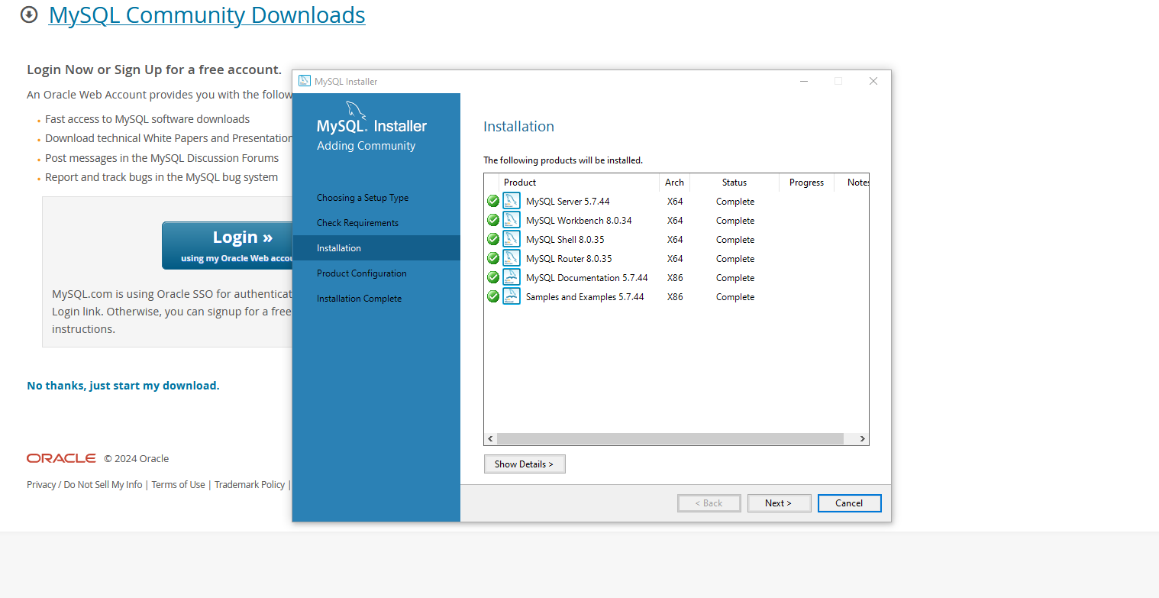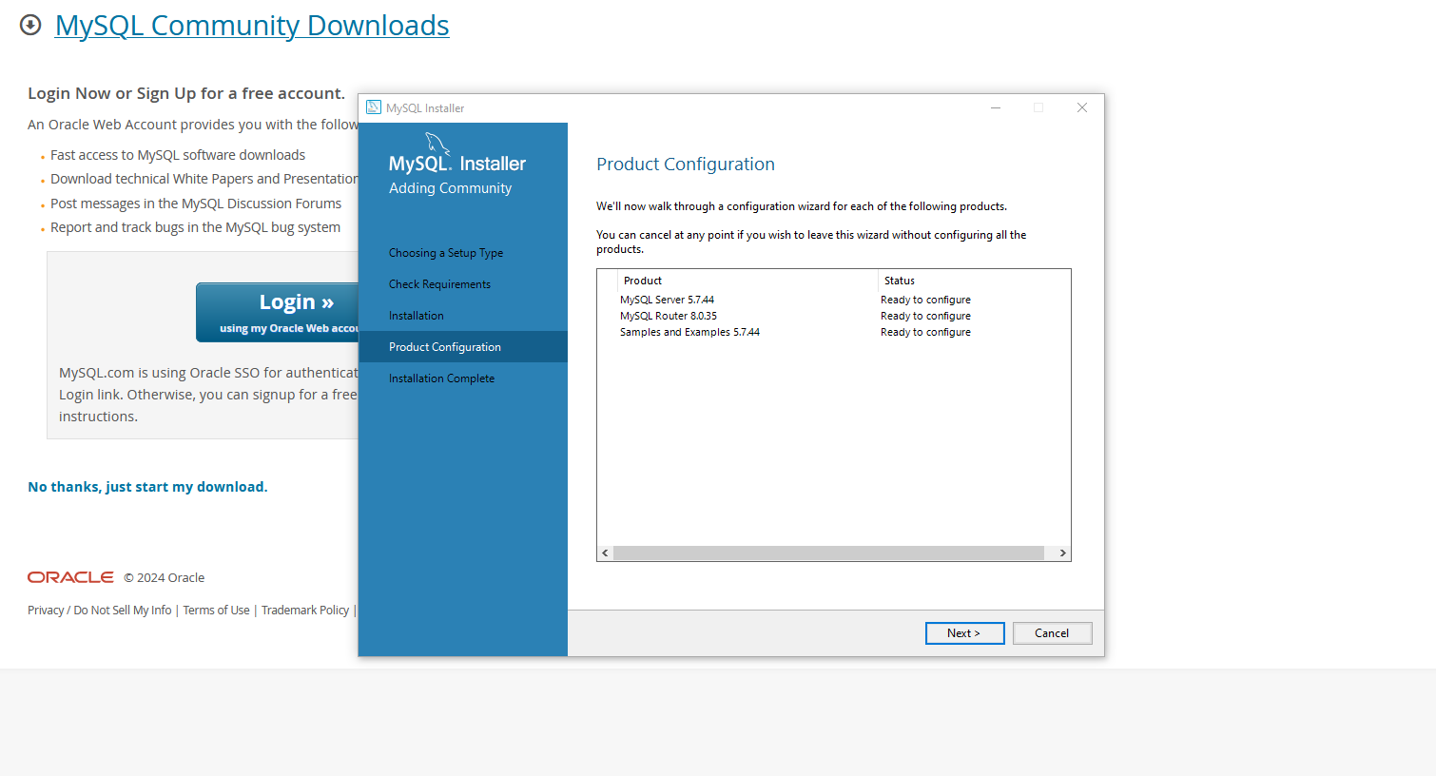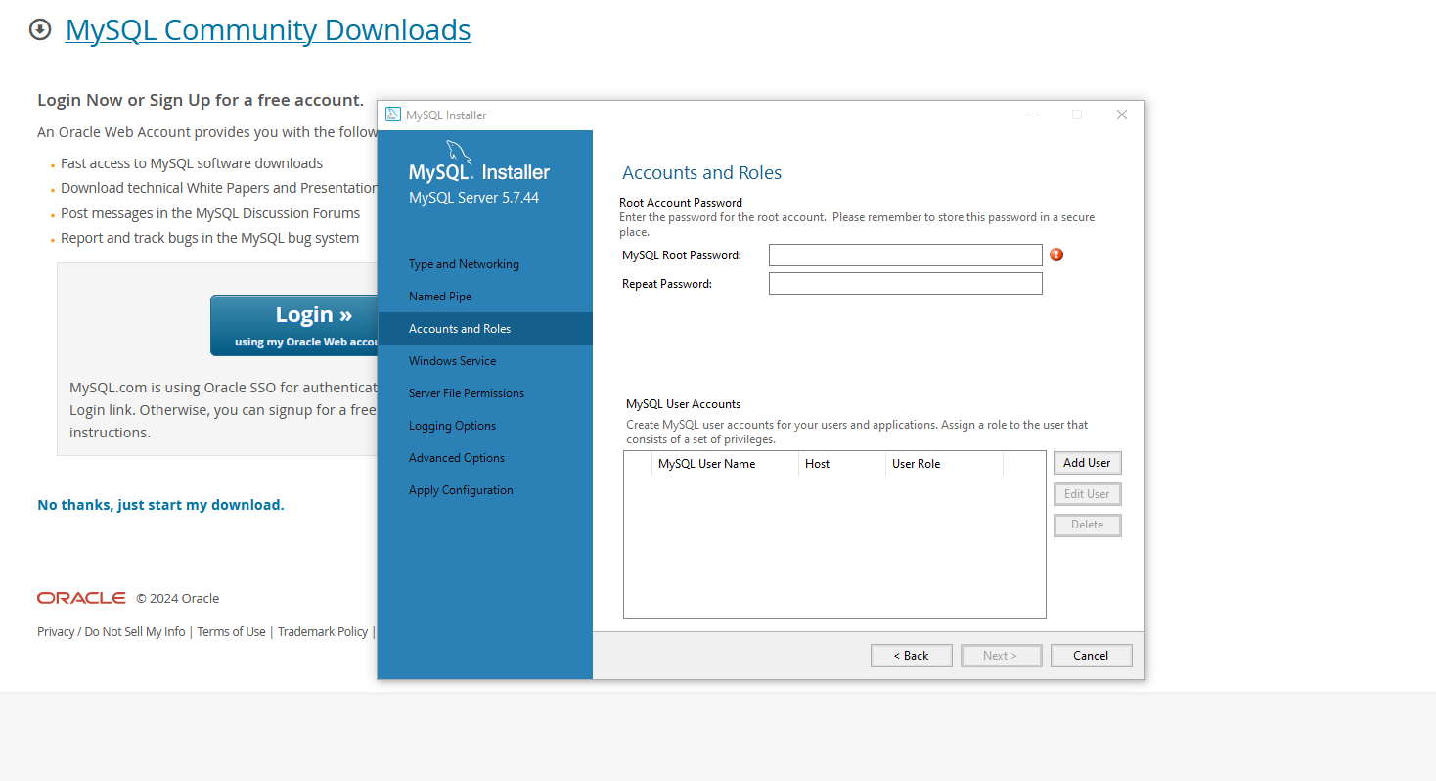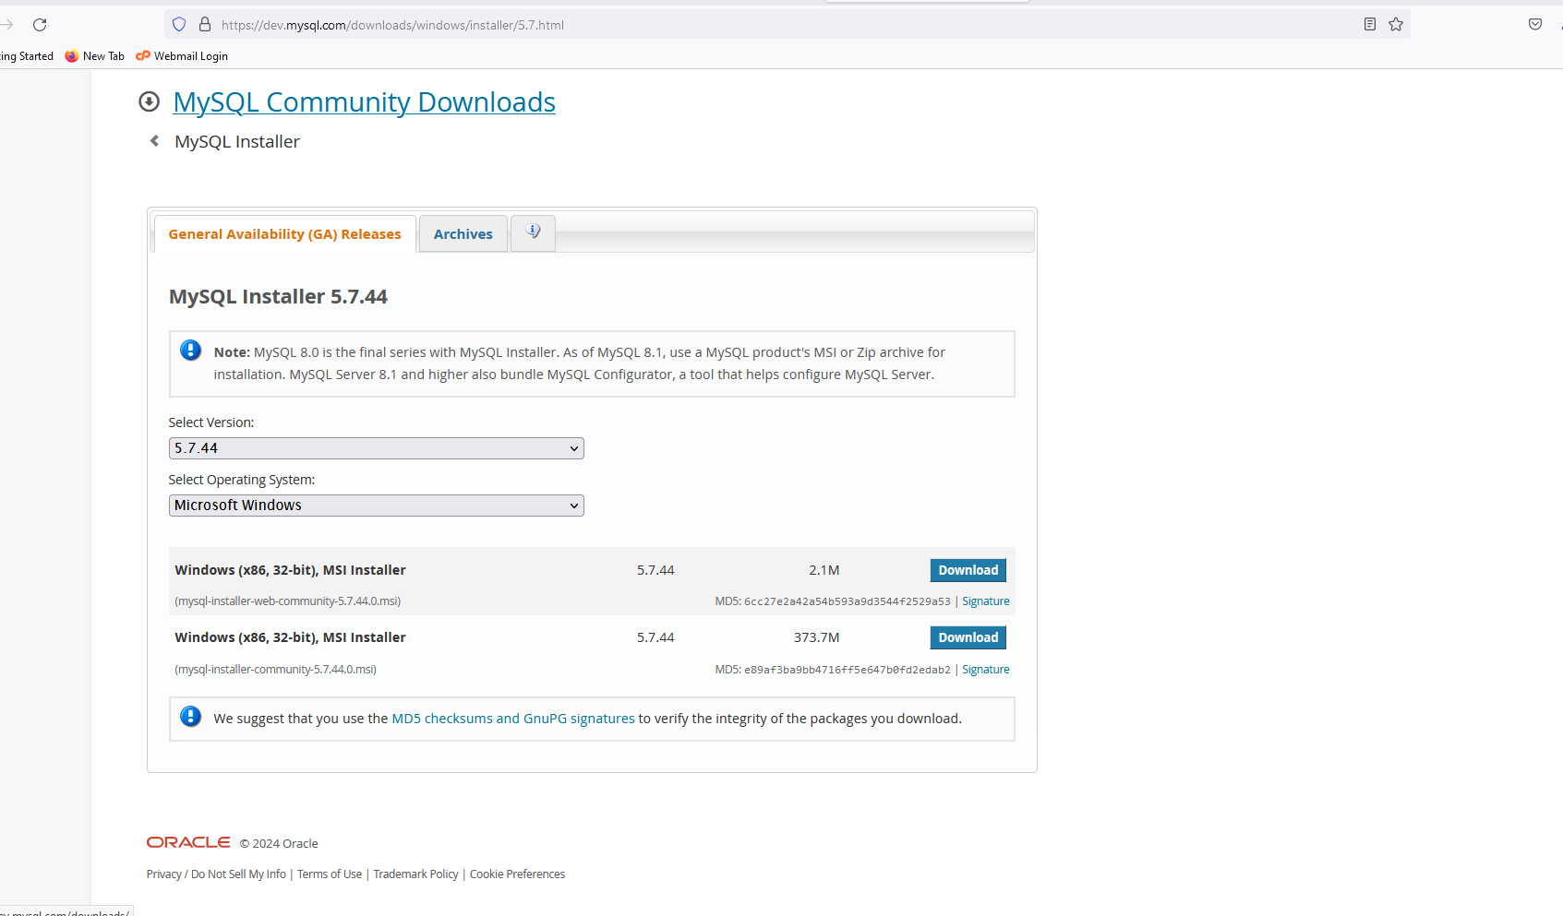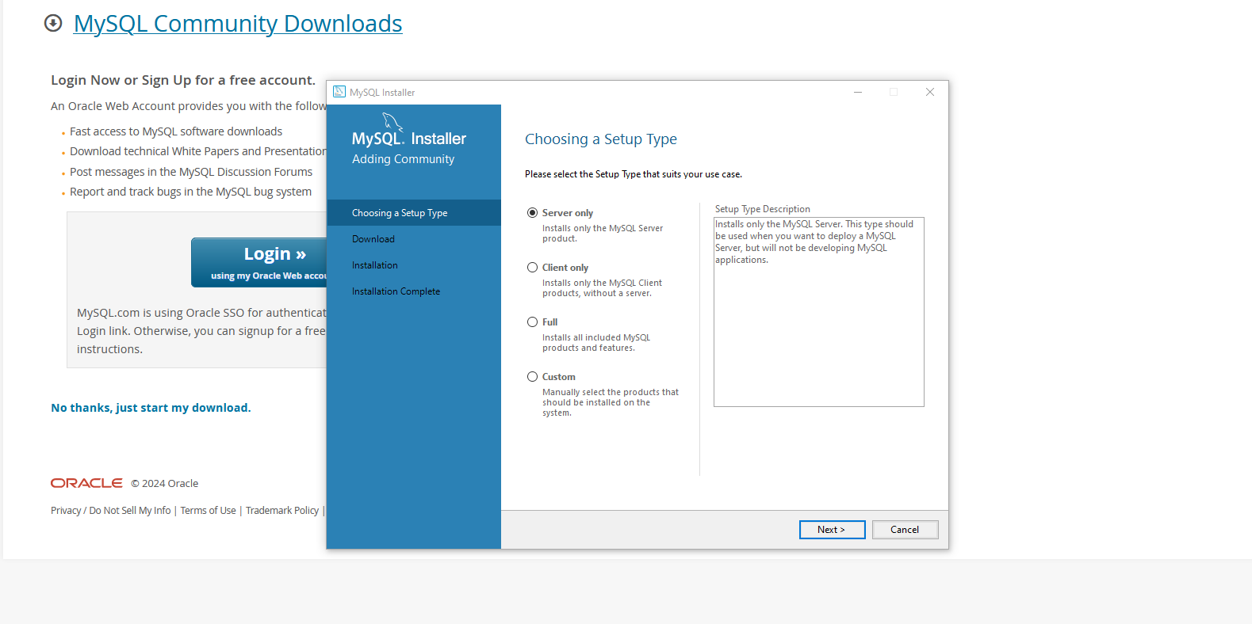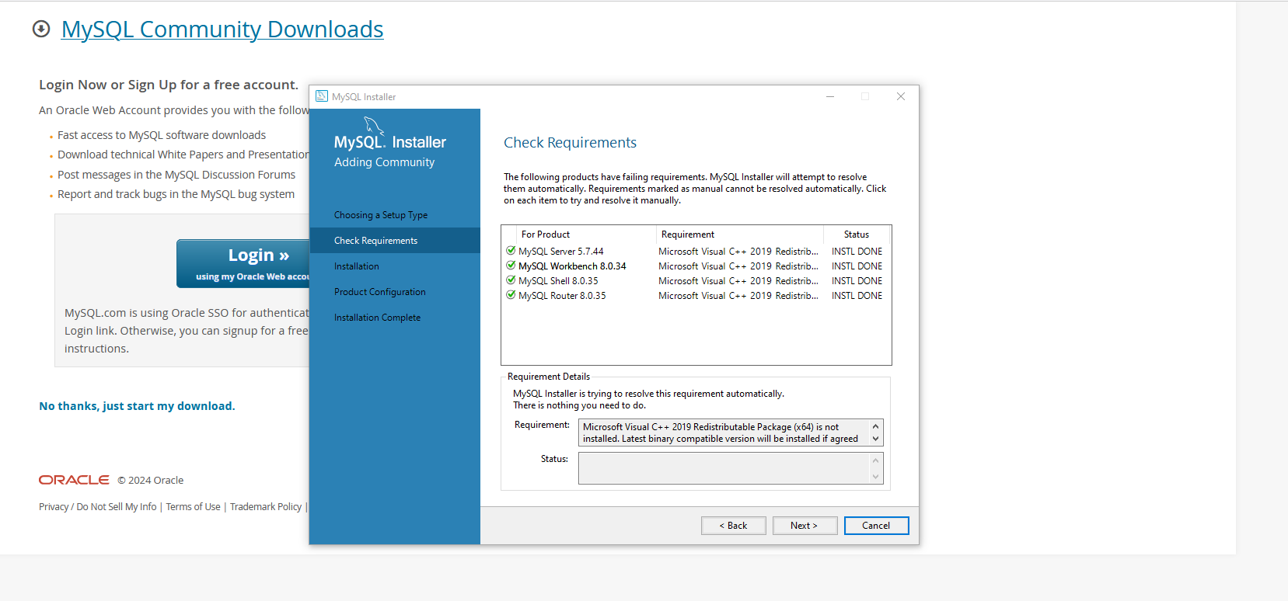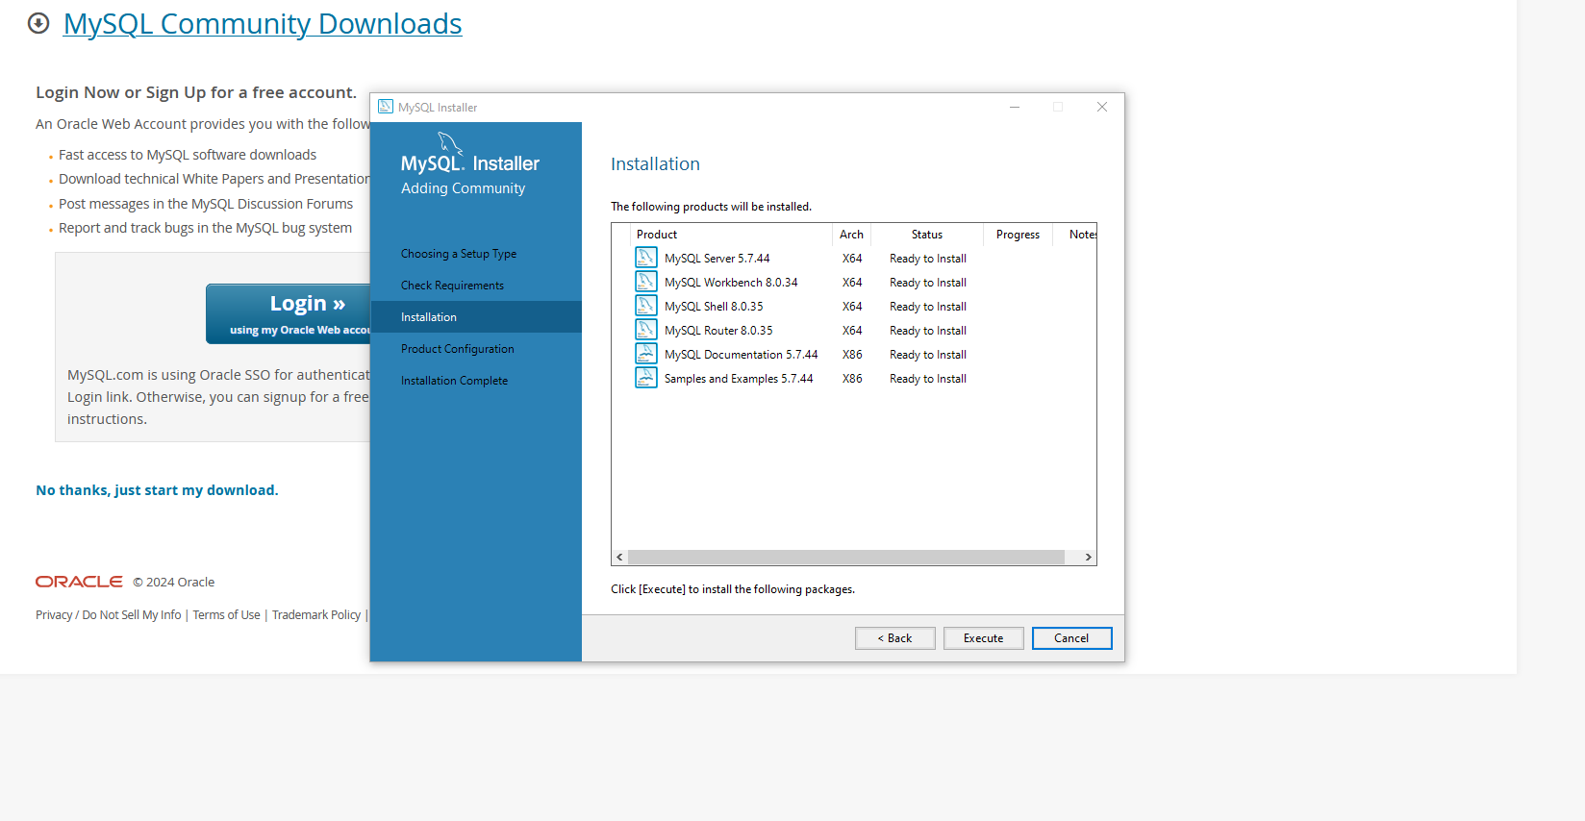**Installed MySQL but unable to configure**

**10. Set Up Development Environments and Virtualization (Optional): Consider using virtualization tools like Docker or virtual machines to isolate project dependencies and ensure consistent environments across different machines.**

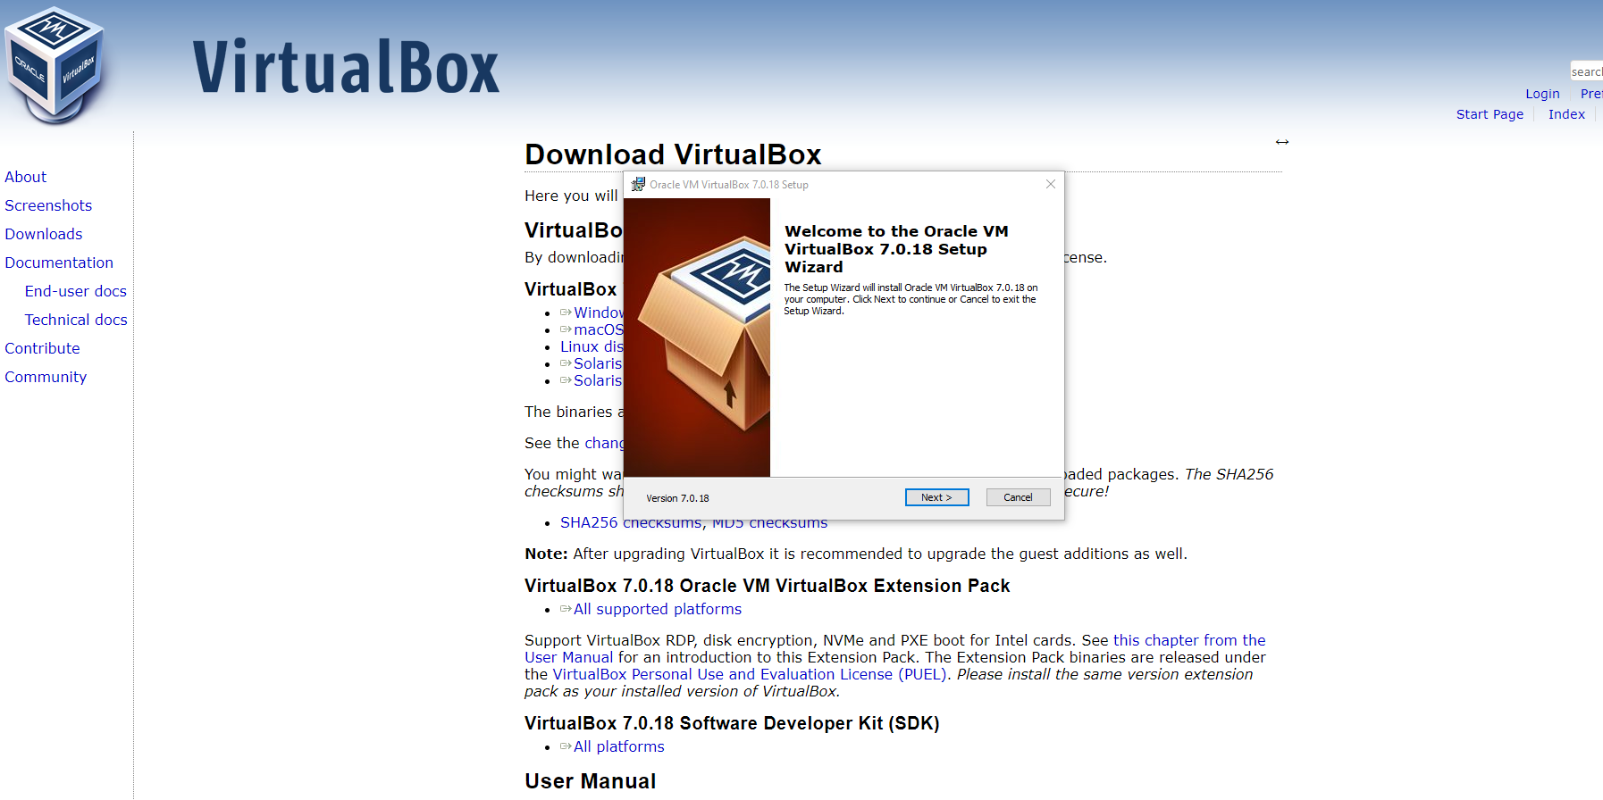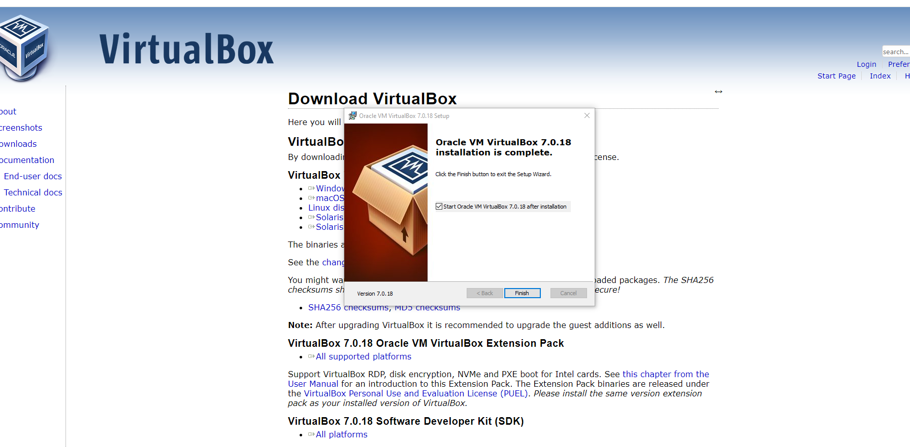

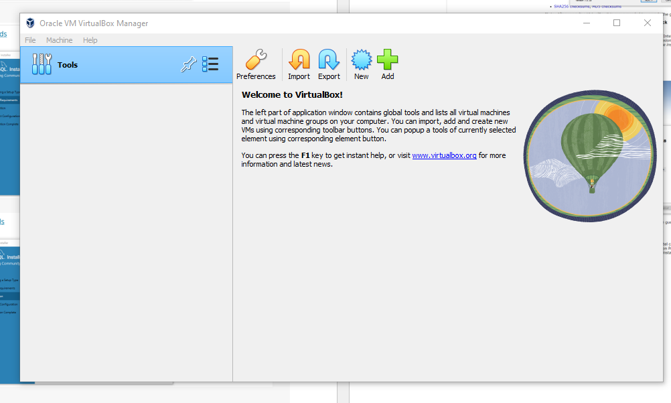

**Successfully installed Virtual Box**